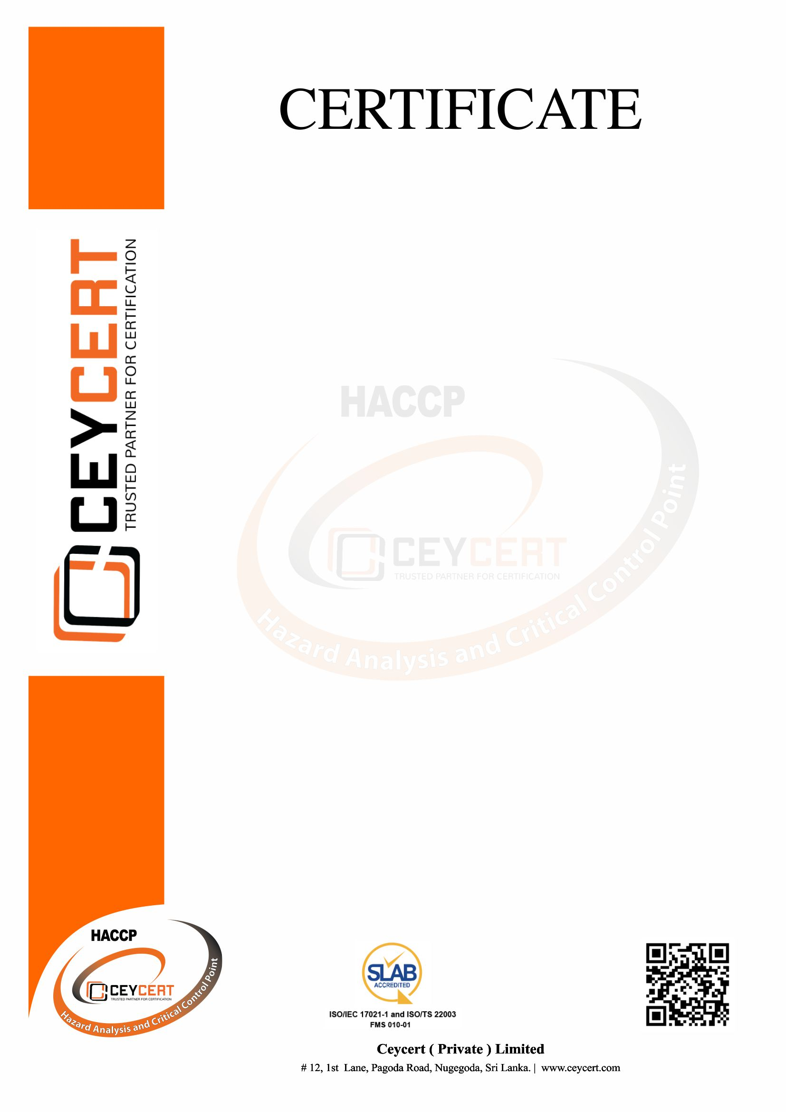

CCHCP 073

C IV

Certificate Number :

Category Code :

: 07-04-2025

: 07-04-2026

: 07-04-2027

**Date of Expiry:** 07-04-2027

Scope of Certification :

Manufacturing of Black Tea & CTC Tea

No: 07, Ginigathhena Road, Rabukpitiya, Nawalapitiya

Liverpool Tea Factory (MF 1596)

**Date of Certification:** 08-04-2024

Surveillance Audit I Before

Surveillance Audit II Before

Recertification Audit Before

**The Requirements of Codex Alimentarius**

**CXC 1-1969:2020**

Ceycert (Private) Limited

Certifies That The Hazard Analysis & Critical Control Point of

Has Been Assessed and Approved in Compliance With