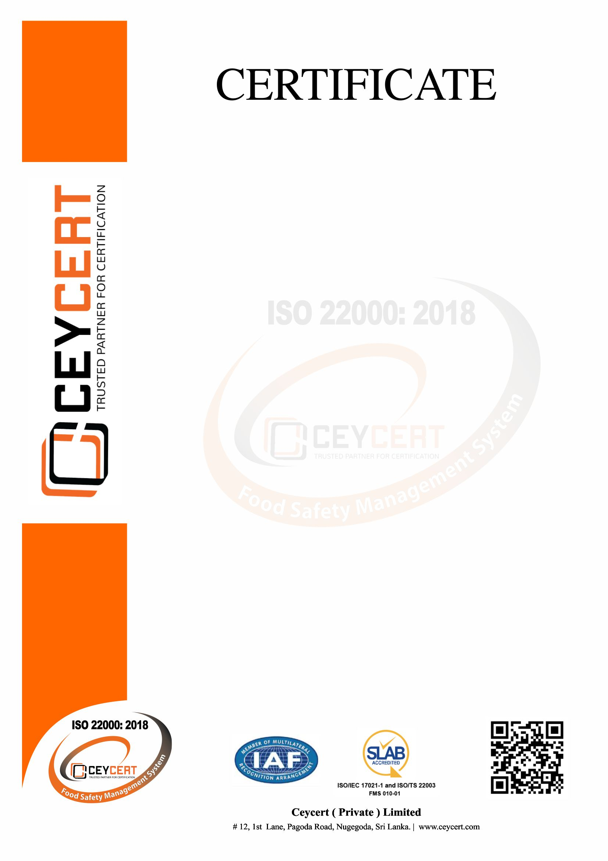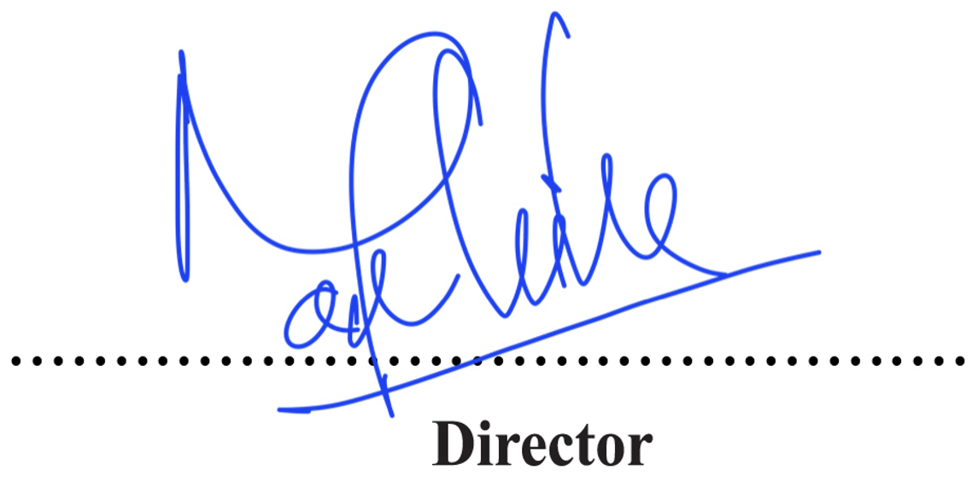

Aditya Birla Global Trading (Lanka)

(Pvt) Ltd

Ceycert (Private) Limited

Certifies That The Food Safety Management System Of

241A, Ambatale Road, Mulleriyawa North, Mulleriyawa

Has Been Assessed and Approved in Compliance With

**The Requirements of ISO 22000:2018**

Certificate No :

Scope of Certification :

Category Code :

Blending, Flavoring, and Packing of Black Tea in Bulk and Retail Packages for Export Market

C IV

CCFS 004

**Date of Expiry:** 21-07-2025

**Date of Certification:** 22-07-2022

: 21-07-2023

: 21-07-2024

: 21-07-2025

Surveillance Audit I Before

Surveillance Audit II Before

Recertification Audit Before